SEASON EXPEXTATIONs

DIVISION FACTS
- Field Location: Lester D. Wilson School
- Field Size: 60’ W x 90’ L
- Goal Size: 4.5’ x 9’
- Game Format: 4 v 4
- Game Length: 4 – 10-minute quarters
- Ball Size: Size 3

Schedule
- Practices: Tuesday and Thursday
- Games: Saturdays

certifications
- Background Check
- Heads-Up Concussion Training

  - DELAWARE VALLEY YOUTH SOCCER CLUB

U8 DIVISION FACT SHEET
What is expected of you as a Volunteer Parent Coach?
Our volunteer coaches are responsible for their team and making sure that all players, parents and coaches abide by the roles and responsibilities laid out in DVYSC By-Laws. You are the face of our organization!

PARENT COMMUNICATION
Communicate with your Parents on a constant basis
Communicate with the parents of your players on a continuous basis. Send out weekly reminders for practices and games. Consider having a team meeting with your parents in the beginning of the season to lay out expectations.
The “Game Changer” App that is connected to our website is available (or use TeamSnap) to help facilitate communications.

Practices
Plan ahead, keep your Players Moving, Have Fun!
DVYSC has provided you with a lesson plan for the season. Please feel free to use this lesson plan in its entirety or use is it as a guide to develop you practice plan. Please keep in mind that we are following US Soccer Player Development Model and at this age we are at the “Me and My Partner” stage in development. DVYSC is here to assist you, if you need help or have a question on a drill please ask!

Game Day responsibilities
What is expected of you on game days?
Please ensure that there are two coaches on the sidelines during games, this is a requirement of DVYSC. If there is inclement weather the DVYSC Board, or their designee, will determine if the games will be played.
During game play all soccer balls that go out of bounds on the sidelines should be returned to play with a kick-in (throw-ins may be incorporated if both coaches agree). All balls that leave play over the goal lines should be restarted with a goal kick (no corner kicks). On the goal kick the opposing team should back up to the midfield line and let the other team build play out from the back. Remember, no goalies teach the defenders to press the ball and not back-up in the goal.
RECOMMENDED FORMATIONS
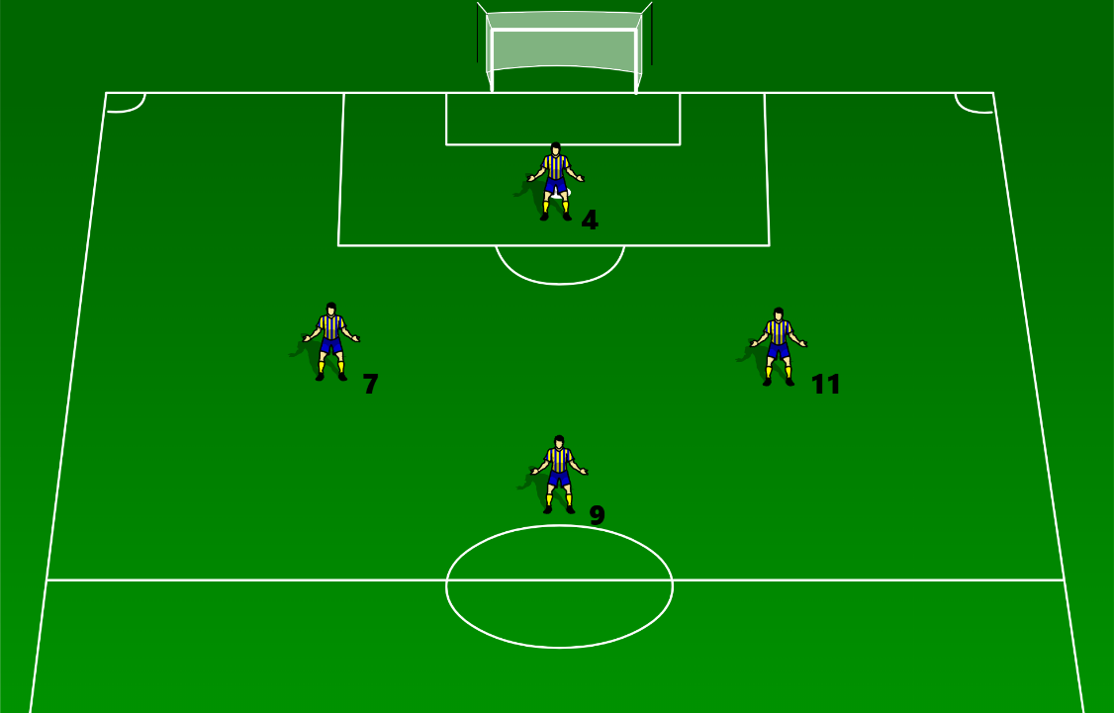 | Formation: 1 – 2 – 1  Benefits:  - Teaches Shape  - Teaches Depth  - Midfield provides support to the Offense and Defense  Drawbacks:  - One Attacker  - One Defender  - Midfielders need to cover
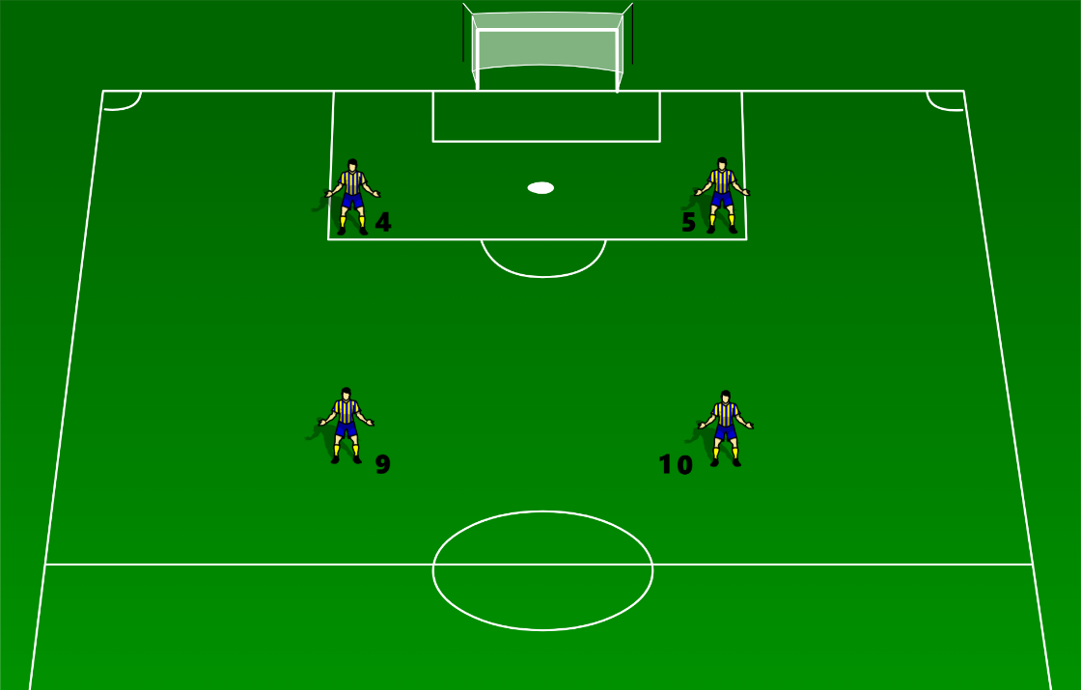 | Formation: 2 – 2  Benefits:  - Balanced  Drawbacks:  - Offense and Defense need a higher work output to support each other
U8 DIVISION FACT SHEET
DELAWARE VALLEY YOUTH SOCCER CLUB

